**1. Create Login Window**

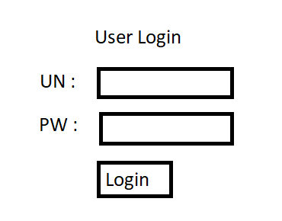

**2. Create User Class**

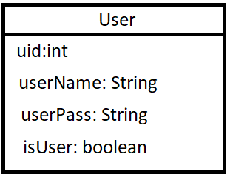

3. Create Class **ManageLogin**

|  |
| --- |
| ManageLogin |
| //receive login info from UI  //send to login  //receive login result  //return login result to UI |